

Research Project Proposal

**TOPIC:** **DATA ANALYTICS TO DETECT CHEATING DURING EXAMS**

**FACULTY**: Information Technology

**DEPARTMENT**: Information Management

**Proposed by**: **FAUSTIN**

**21…**

**Phone**: 0788858753

**Email**: fautin@gmail.com

Done at Kigali, 31st Jan 2024

**PART I**

**AS IS PROCESS MODEL**

**Background of the study**

Technology has been an influential factor in all aspects of human being's daily life. It has never hesitated to be involved in education. In fact, technology has revolutionized the way education is delivered and accessed. It has made learning more accessible and interactive than ever before.

Cheating is one of the challenging factor when it comes to the efficiency of education. Teachers spend a lot of energy, time and money to deal with cheating.

This has therefore made me think of how I can minimize the cheating probability using the skills that I have acquired throughout my education career.

**Description of the current system**

Currently teachers spend a lot of time, energy and money to supervise the students during exams. This includes setting up a secure testing environment, monitoring students to prevent cheating, and grading the exams afterwards. However, with the advancements in technology, there is an opportunity to reduce the burden on teachers by implementing online proctoring systems. These systems use algorithms to monitor students remotely, ensuring exam integrity while saving teachers time and resources. By embracing online proctoring, teachers can focus more on providing quality education and personalized instruction to their students.

**MODELING THE CURRENT SYSTEM**

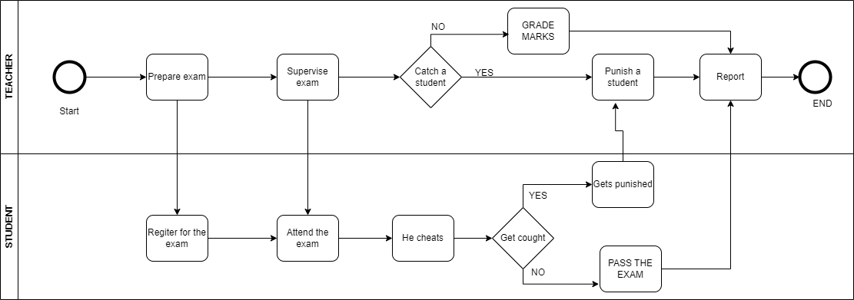

**PART II**

**PROBLEMS WITH THE CURRENT SYSTEM**

The current system has a number of weaknesses and flaws. Some of them are briefed down here.

**Time consuming**

The current exam preparation and supervision system environment which relies on human invigilators is not only time-consuming but also prone to errors. Therefore, there is a pressing need for an automated system that can streamline the process and ensure fairness and accuracy. With advancements in technology, the introduction of computer-based proctoring software can revolutionize the exam preparation and supervision system. This intelligent system can monitor students remotely, detect any suspicious behavior, and prevent cheating, ultimately improving the overall integrity of the examination process.

**Production Rate**

The current system is not productive, often resulting in delays and inaccuracies. However, with the implementation of computer-based proctoring software, exams can be conducted smoothly and seamlessly. This automated system not only saves time but also minimizes errors, providing a reliable and fair evaluation for all students. Additionally, the use of remote monitoring and behavior detection further ensures the integrity of the examination process, creating a level playing field for all participants. Overall, the introduction of computer-based proctoring software is a necessary step towards modernizing the examination system and ensuring its efficiency and accuracy.

**Efficiency**

The current system's accuracy is very low. Teachers are humans, and humans are likely to be inefficient. By introducing computer-based proctoring software, the reliance on human proctors is eliminated, reducing the chances of errors and inefficiencies. This automated system is capable of monitoring and evaluating multiple students simultaneously, ensuring a fair and accurate assessment for all. Moreover, with remote monitoring and behavior detection, the software can detect any suspicious activities and maintain the integrity of the examination process. Therefore, the implementation of computer-based proctoring software not only modernizes the system but also significantly improves its accuracy and efficiency compared to the current human-dependent approach.